John Michael Go
Career Entry Level Java Programming
Date: Jan. 17, 2013

DAY 5

Program Name: DateTime2

Objective: Second Date and Time example

Algorithm:

- Program outputs second date and time format.

Flowchart:

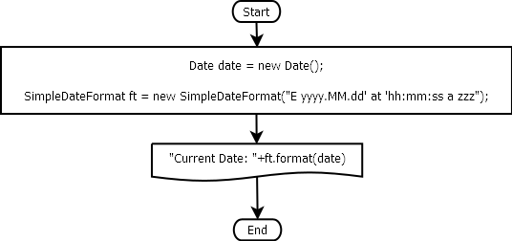

Pseudocode:

/* Program Name: DateTime2
Created By: John Michael Go
Creation Date: Jan. 17, 2013 Day 5
Note: Second Date and Time example
*/

import java.util.Date;
import java.text.*;

public class DateTime2{

public static void main(String[]args){

Date date = new Date();

SimpleDateFormat ft = new SimpleDateFormat("E yyyy.MM.dd' at 'hh:mm:ss a zzz");

System.out.println("Current Date: "+ft.format(date));

System.out.print("");

}

}

Screenshot:

